Documentation

Introduction: Reel Jet is a professional movie application that provides users with a vast collection of free movies and films. This documentation serves as a guide to understanding the features and functionality of the application.

* Features:
  + a. Extensive Movie Collection: Reel Jet offers a diverse range of movies and films for users to explore and enjoy.
  + b. Film Education: Users can access information and learn about various films and movies within the application.
  + c. Favorites Section: If you love a particular movie or film, you can add it to your favorites section for quick access and future viewing.
  + d. History Tracking: The application keeps a record of your viewing history, allowing you to easily revisit previously watched movies.
* Getting Started:
  + a. Download and Installation: Visit the official Reel Jet website and download the application for your device. Follow the installation instructions to set it up.
  + b. User Registration: Create an account within the application to personalize your experience and access additional features.
  + c. Browsing Movies: Use the intuitive user interface to browse through the extensive movie collection. Utilize filters and search functionality for efficient navigation.
* Movie Details:
  + a. Movie Information: Each movie listing includes essential details such as title, genre, release year, and a brief synopsis.
  + b. Cast and Crew: Explore the cast and crew members associated with a particular movie.
  + c. Ratings and Reviews: Gain insights into user ratings and reviews to help you make informed decisions on movie selection.
* Favorites and History:
  + a. Favorites Management: Add movies to your favorites section by selecting the appropriate option. Remove movies from favorites when desired.
  + b. Viewing History: Access your viewing history to quickly find and resume previously watched movies.
* Account Settings:
  + a. Profile Customization: Personalize your profile within the application by adding a profile picture and updating your preferences.
  + b. Notifications: Manage notification settings to stay updated on new movie releases and recommendations.

Conclusion: Reel Jet is a feature-rich movie application that offers a diverse collection of free movies and films. With its educational resources, favorites section, and history tracking, Reel Jet provides an immersive movie-watching experience. Enjoy exploring the world of cinema right at your fingertips with Reel Jet.

You can also see design of pages from below:

**Loading Page**



**Login Page**

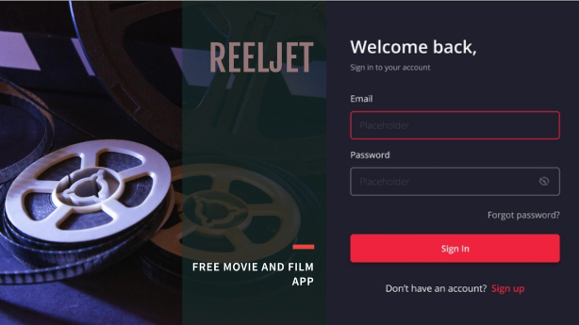

**SignUp Page**

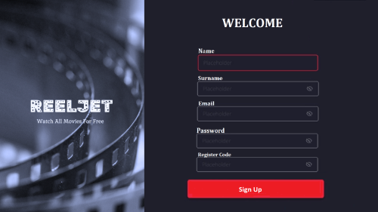

**MoviesListViewItem**



MovieListPage

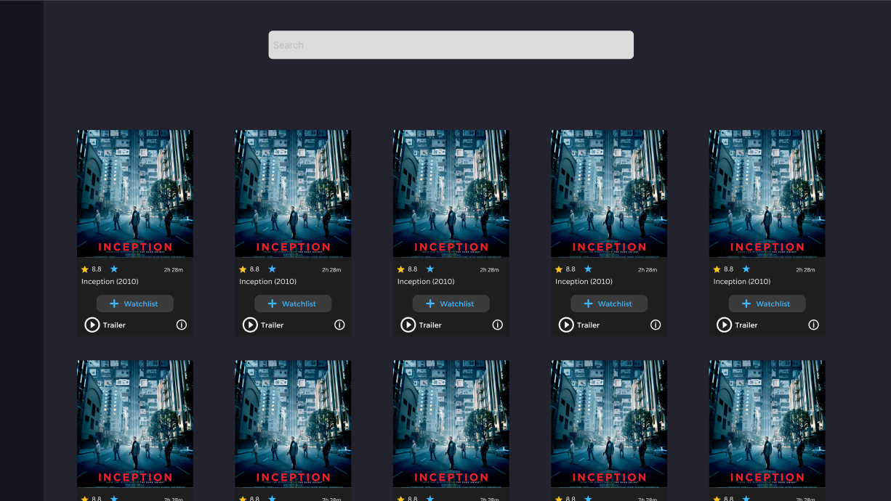

MoviePreviewPage

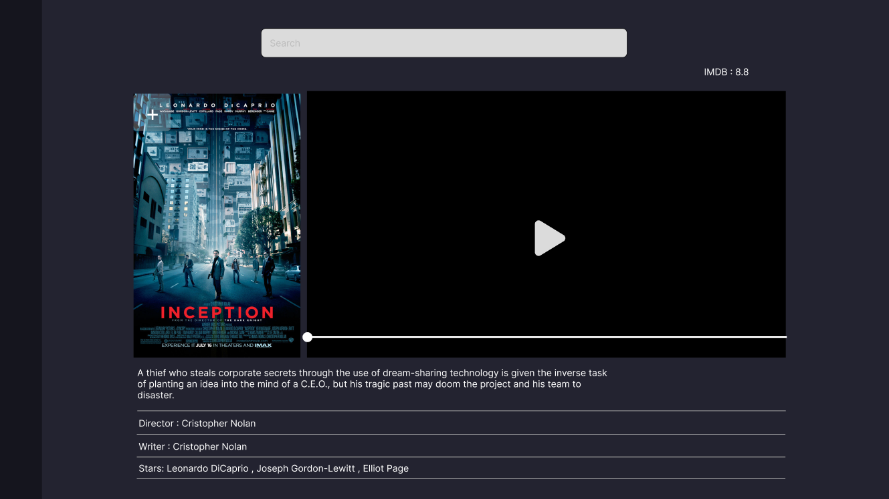

WatchMoviePage



History Page

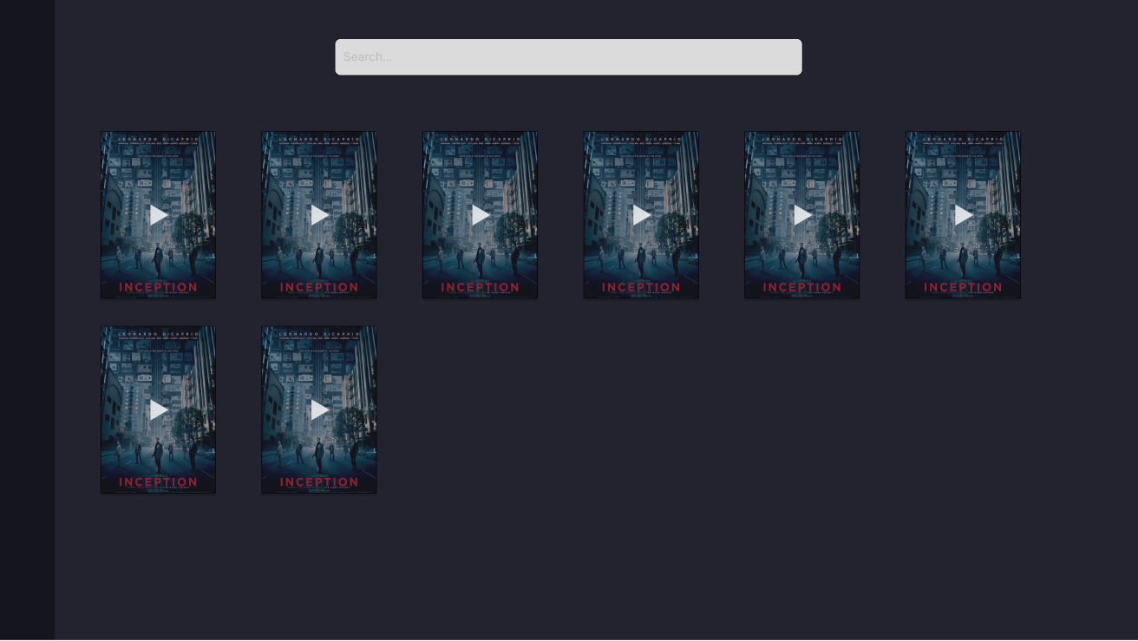

WatchList Page

